Amazing Raptor Migration & number one Jungle Birding
Panama, 10 days

Put together your own group and receive significant discounts!
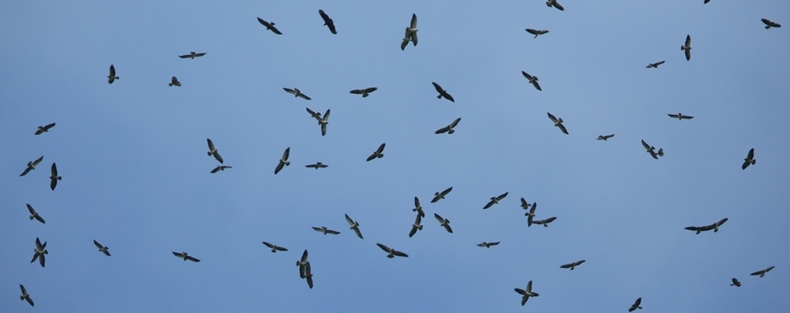
This tour is a superb combination of a spectacular massive raptor migration, number one in the World with some easy, lowland tropical rainforest birding with many sought after species. The constant flow of Hawks, Vultures, Kites blacken the sky; we can easily see over a million of birds within a few days. Our record was 1.2 milion birds within a few hours! Add a huge variety of rare and colourful tropical denizens such as Blue Cotinga, dozens of Hummingbirds, 5 Trogon species, Motmots, Toucans, Woodpeckers, Puffbirds, Manakins, Purple-throated Fruitcrow, Chuck-will’s-widow, about 30 species of Flycatchers, various Anthshrikes, Antwrens, Antbirds, Ant-thrushes & Antpittas, Green Shrike-Vireo, Wrens, tropical Warblers, Caciques & Orioles, dazzling variety of Tanagers. Beautiful butterflies & some interesting mammals such as Sloths or Geoffrey's Tamarind Monkey will colour the scene during this easy birding tour.
.
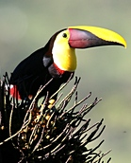
Fact File
- 10 birding days in Panama, watching the world-famous Raptor migration & visiting National Parks and nature reserves for tropical lowland rainforest birding
- start and finish in Panama City
- using 2 accommodations with great on site birding
- very short daily transfers

Highlights
- daily Raptor Watching from top of a hill
- birding at word famous sites such as Metropolitan Nature Park, Panama City Wetlands, rainforests of Pipeline Road & Ammo Ponds at Soberanía National Park and other areas
- wide variety of birds, plus some mammals, reptiles, butterflies and interesting habitats
Accommodation
5 nights at the foot of the most famous Raptor watching point in Panama City
3 nights at Gamboa Reserve
Extension possibility to either Western Panama (either Bocas del Torro or La Amistad or Boquete) or Eastern Panama, Darien region.

Our price includes
- all travel within the country as noted in the itinerary;
- all accommodation based on shared rooms, single rooms for extra charge;
- 3 meals per day, generally breakfast, packed lunch, dinner (consists of at least two courses);
- services of the leader(s);
- trip materials.

Activity level
Easy to moderate walks; some areas are hot and humid; rain is possible

Not included
- flights to and from Panama City;
- optional programmes to places of interest and entrance fees involved;
- airport and other departure taxes, tips; food beyond generally 3 meals/day;
- excess baggage charges; telephone calls; alcoholic beverages;
- compulsory personal insurance.

Itinerary – please note that we have different tour variations & can tailor-make offers
Vistied areas, trails and daily trips can vary depending your needs and actual birding info.

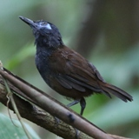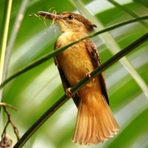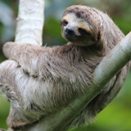

Day 1
Arrival to Panama City and transfer to our hotel, birding on site.

Days 2-5 Panama City Area
Each morning we can start birding in our hotel garden and in the tranquil green area nearby which has a long list of various species such as White-necked Jacobin, Black-throated Mango, Garden Emerald, Rufous-tailed Hummingbird, Blue-chested Hummingbird, Lineated Woodpecker, Orange-chinned Parakeet, Yellow-crowned Tyrannulet, Yellow-bellied Elaenia, Southern Beardless Tyrannulet, Common Tody-Flycatcher, Streaked & Boat-billed Flycatcher, Fork-tailed Flycatcher, Red-eyed Vireo, Swainson's Thrush, Clay-colored Robin, Yellow Warbler, Variable Seed-eater, Crimson-backed-, Blue-gray, Summer and Palm Tanager, Yellow-crowned Tanager.

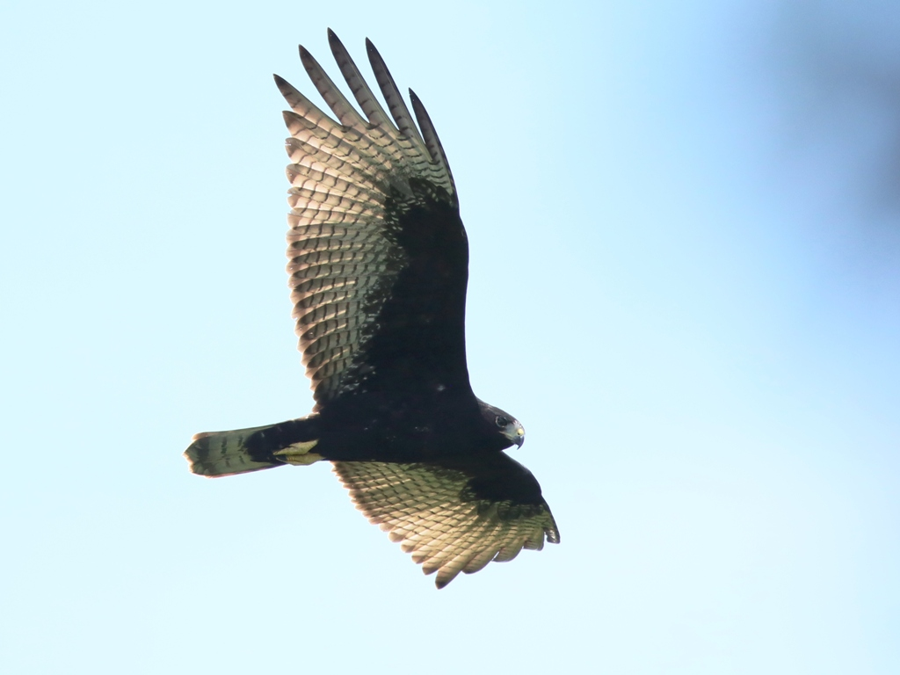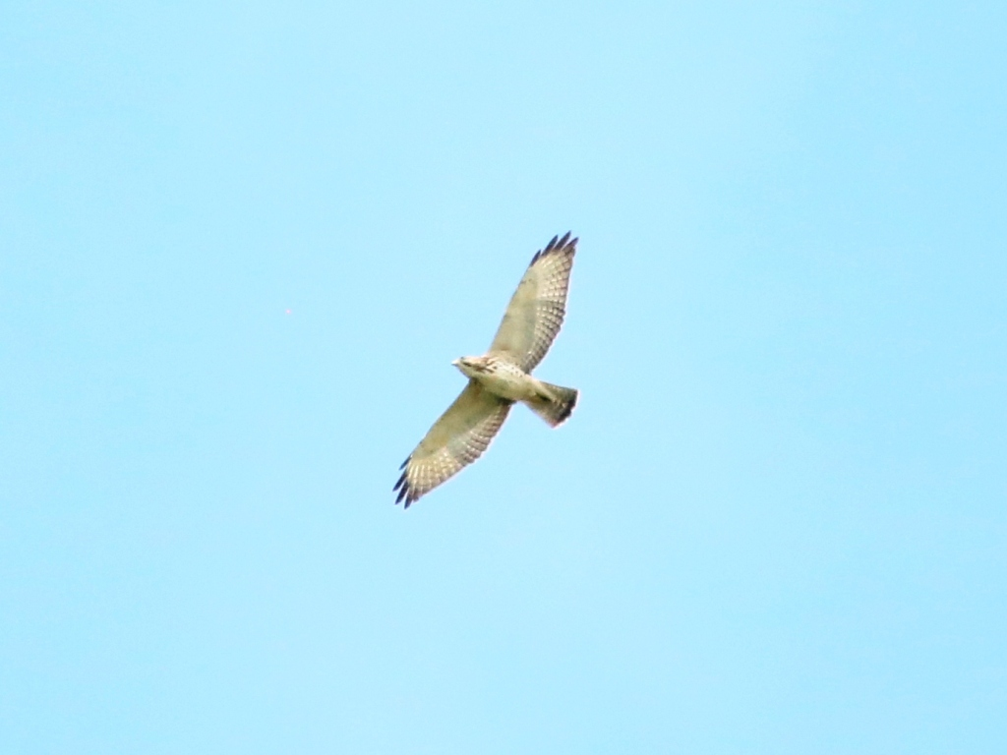

Each morning after breakfast if the weather is suitable we drive up to the top of a nearby hill which offers a perfect panoramic view of the large kettles of migrating raptors. End of October, beginning of November is the peak time for mainly hundreds of thousands of Swainsson’s, Short-tailed and Broad-winged Hawks, but we might be lucky to see some late Swallow-tailed Kites or Mississippi Kites as well. From time to time we point out a Zone-tailed Hawk or a Yellow-headed Caracara or a fast Peregrine Falcon or a fishing Osprey or a hunting Crane Hawk. We picked up some rarer species as well, such as Gray-lined Hawk or King Vulture. On our last tour we also found both Chuck-will's Widow and Lesser Nighthawk.

On a good day the sheer number of birds in the sky can be stunning. On one day we witnessed a constant River of Raptors flowing in front of us with more than 1.2 million birds within just a half day!

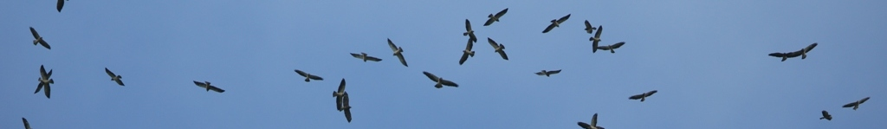

On one of the days we spend a few hours at the Metropolitan National Park where we can find Gray-headed Chachalaca, Black-crowned & Yellow-crowned Night Heron, Barred Antshrike, Southern Rough-winged Swallow, Prothonotary Warbler, Saffron Finch.

Another day we can discover the Bayano Lowland area which can produce Little Tinamou, Wood Stork, Green & Cocoi Heron, Anhinga and we can add a few more raptors such as Crested Caracara, American Kestrel, White-tailed Kite. Further new species can be Blue Ground Dove, Red-lored Parrot, Smooth-billed Ani, Common Nighthawk, Pale-bellied Hermit. We try to find local specialities such as Black-tailed Trogon, Stripe-cheeked Woodpecker, Pied Puffbird, Golden Collared Manakin, Fasciated Antshrike, Black Antshrike, Western Slaty/Black-crowned Antshrike, Dusky and Jet Antbird, Bay Wren, Bay-breasted Warbler and the very localized Streaked Xenops.

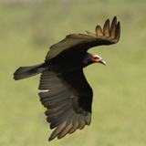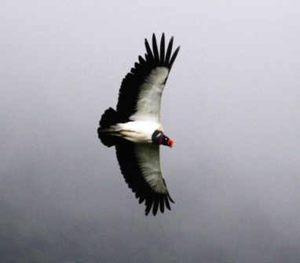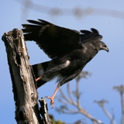

Days 6-9 Tropical Lowland Birding

Each day we discover different parts of the Gamboa Forest, Soberania National Park and other World-famous trails, such as Pipeline Road, Plantation Road or El Charco.

Travelling distances are short every day, walks are generally on flat area, but it can be humid especially after occasional rains. The potential list of birds is extremely long, here we mention some of those which we saw during our last tour: Great Tinamu, Muscovy Duck, Rufescent Tiger Heron, Agami Heron, Boat-billed Heron, Tricolored Heron, King Vulture, Bat Falcon, Snail Kite, Ornate Hawk-Eagle, White-throated Crake, Gray-necked Wood Rail, Purple Gallinule, Scaled Pigeon, Mealy Parrot, Greater Ani, Lesser Swallow-tailed Swift. A dazzling variety of hummingbirds will wait for us, such as Western Long-tailed and Stripe-throated Hermit, Purple-crowned Woodnymph, Violet-bellied and Blue-chested Hummingbird, White-vented Plumeleteer.

We have a good chance for all 5 possible Trogon species: White-tailed, Violaceous, Black-throated, Slaty-tailed and Black-tailed. Also we should find Blue-crowned, Rufous and Broad-billed Motmot. Other colourful species can be Collared Aracari and Chestnut-mandibled Toucan.

We usually get some unique Woodpecker species such as Black-cheeked, Cinnamon and Crimson-crested. Also we should find White-necked and Black-breasted Puffbird.
Some of the notable highlights of tropical birding is Blue-crowned and Lance-tailed Manakin, but Blue Cotinga and Purple-throated Fruitcrow can steal the show.

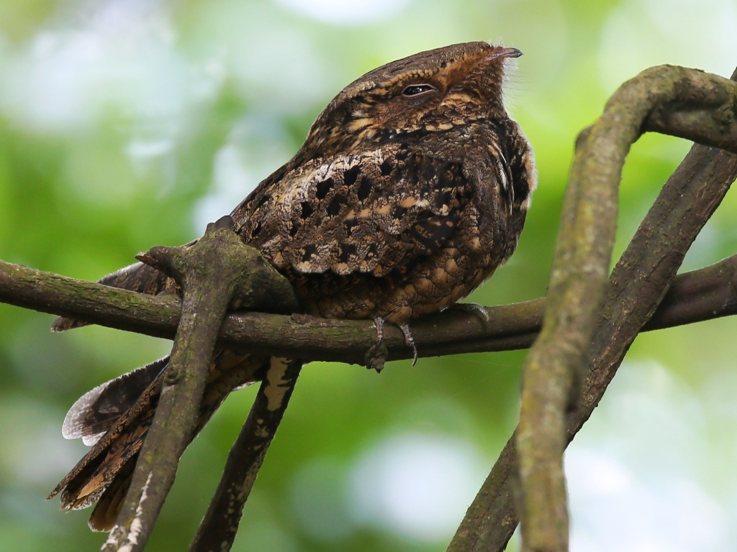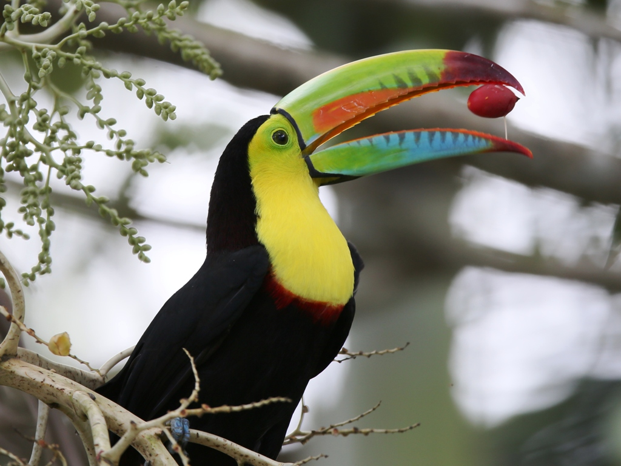

We surely will take time to identify as many flycatcher species as possible which is usually above 2 dozens, including Southern Bentbill, Eye-ringed Flatbill, Ruddy-tailed and of course Panama Flycatcher.
Antshrikes will be represented by Fasciated and Western Slaty/Black-crowned, Antwrens include Checker-throated, White-flanked and Dot-winged while we have a good chance for several Antbirds as well such as Dusky, White-bellied, Chestnut-backed, Bicolored and Spotted. With some luck we can find Black-faced Ant-thrush and Streak-chested Antpitta as well.

Finally we will try to find Green Shrike-Vireo, Black-bellied Wren, tropical Warblers, Caciques & Orioles, Scaly-breasted/Southern Nightingale Wren, dazzling variety of Tanagers including Rosy-thrush Tanager and the strangely, but aptly named Brownish Twistwing.

Days 9-10
Finally we return to Panama City airport for our flight and arrive back home the next day.

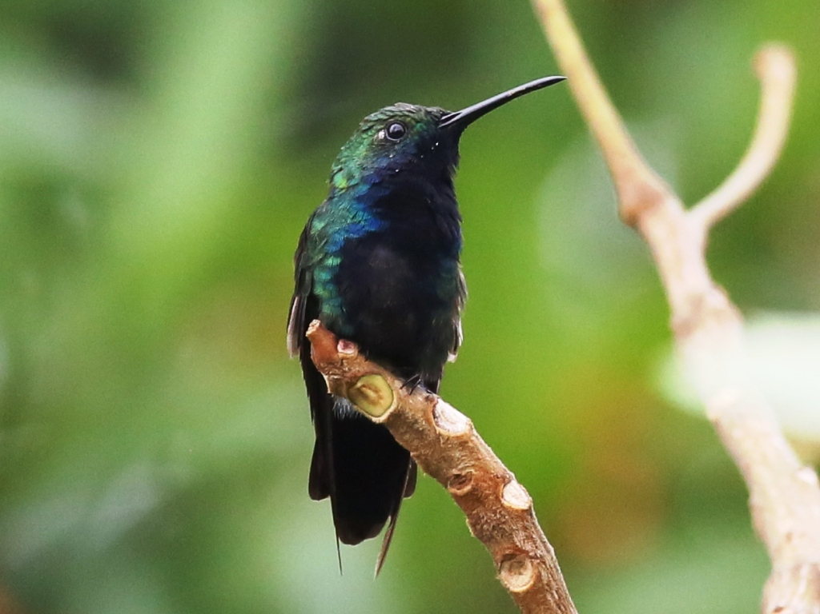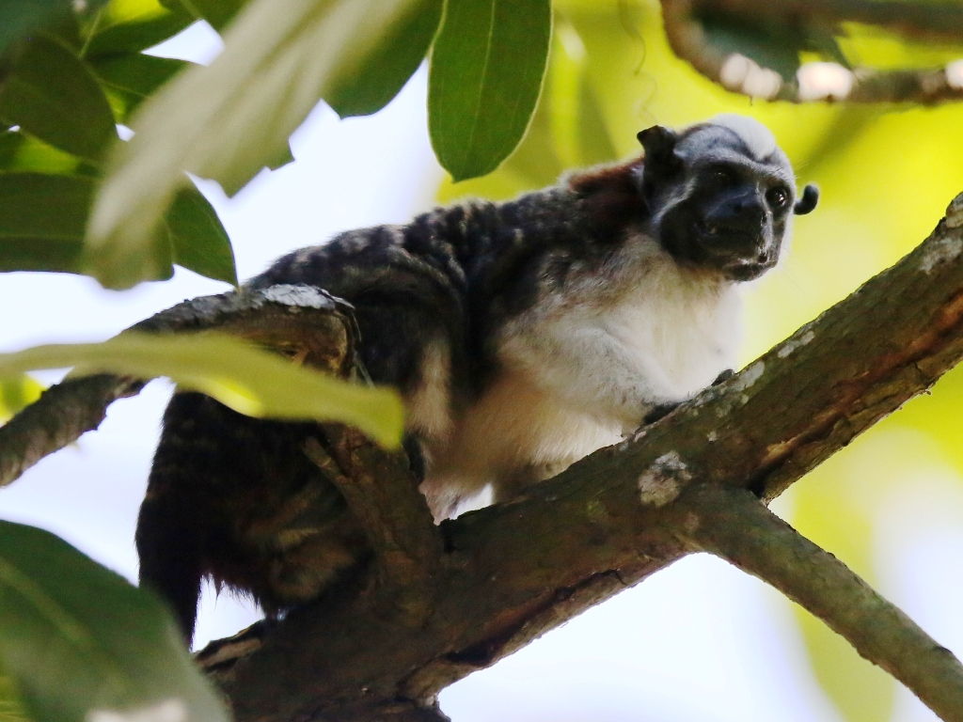
Put together your own group and receive significant discounts!

